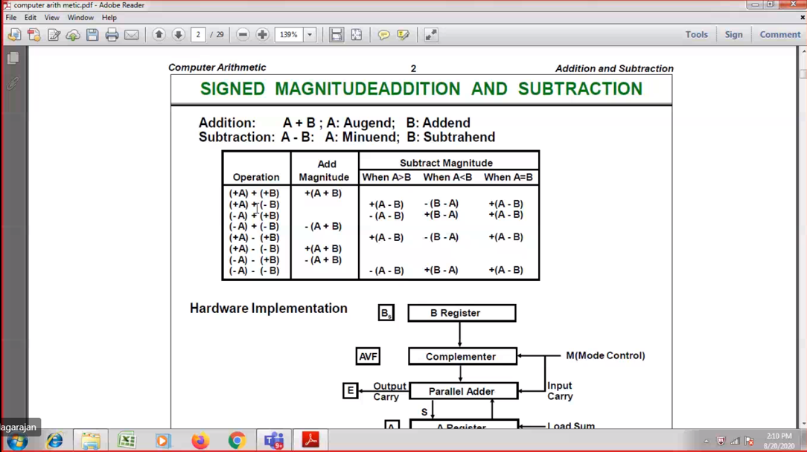



A and B register 🡪 To store the numbers

As and Bs 🡪 sign magnitude (Only for the purpose of sign)

AVF 🡪

E 🡪 carry term



Complementor 🡪 Subtraction purpose 🡪 2’s completement of subtrahend, then add with minuend  
 (1’s complement + 1)



Mode controller 1🡪 -ve and 0 🡪 +ve



The resultant is stored back in A register.

**Without sign consideration so no A’s and B’s**

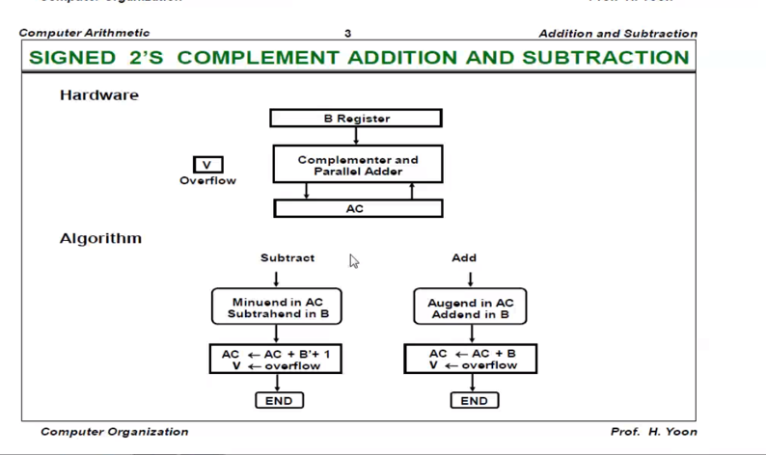



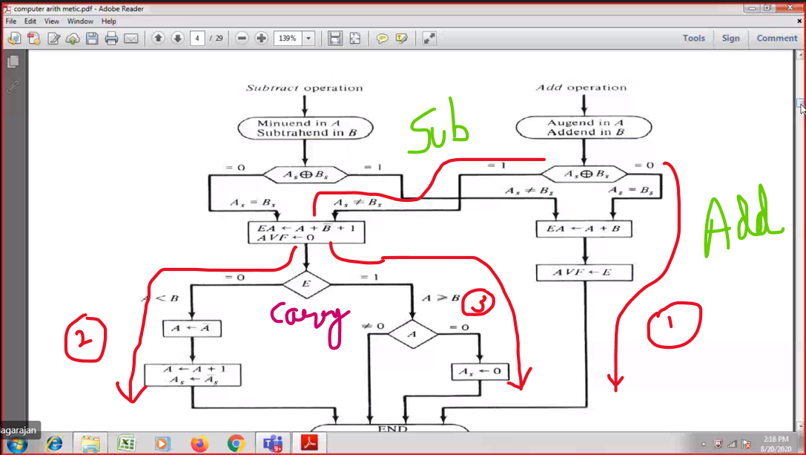

As + Bs 🡪 EXOR gate, when both the inputs are same 🡪 0  
 when both the inputs are different 🡪 1

(1010 + 1100) As = +ve and B’s = +ve  
(1010 - 1100) As = +ve and B’s = -ve



If E=0, then A<B

If E=1, then A>=B

If A=0, then all the ans are 00000( i.e positive ). So change the sign bit As<-0 ( Indicating +ve)

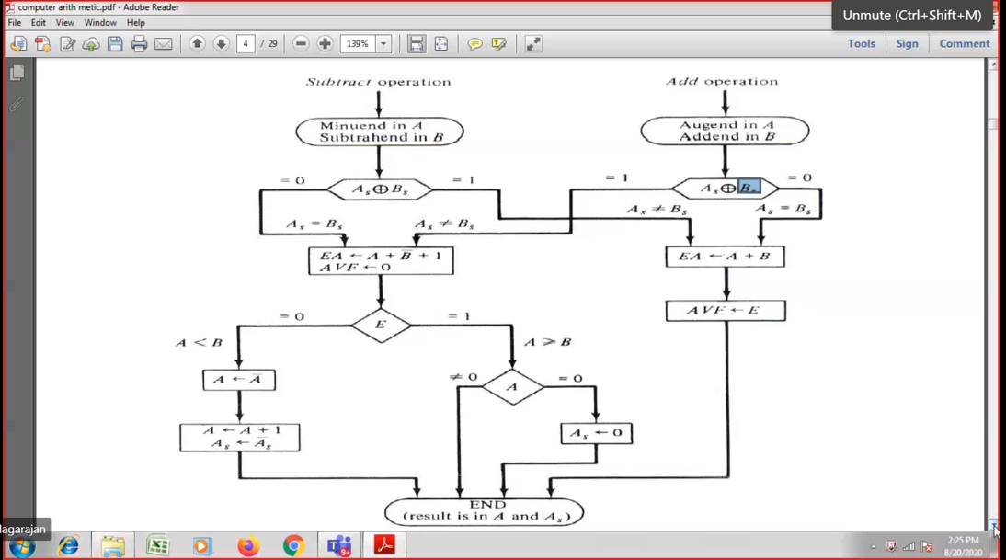



( (+10100) - (- 11000) ) 🡪 As=+ve and Bs=-ve   
( (+10100) - (+ 11000) ) 🡪 As=+ve and Bs=+ve



Final ans is in A and sign of final ans is in As

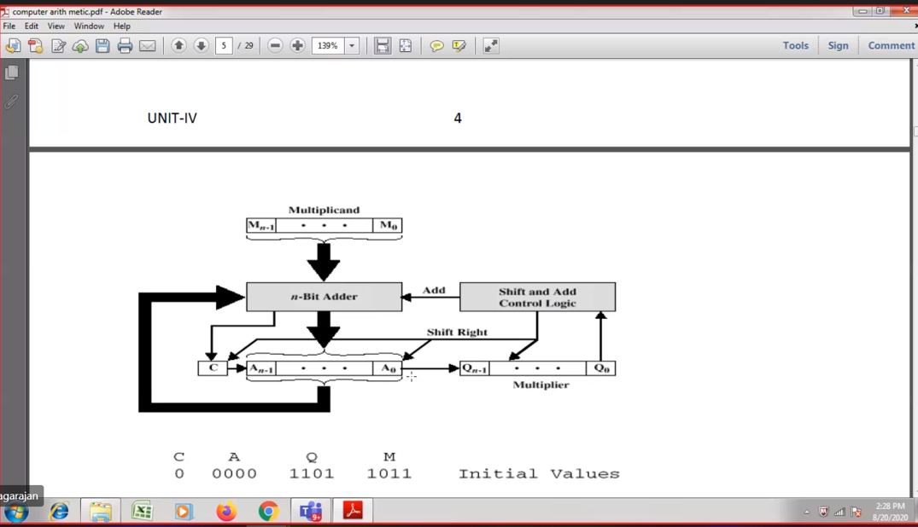



Carry Accumulator (to store the resultant)

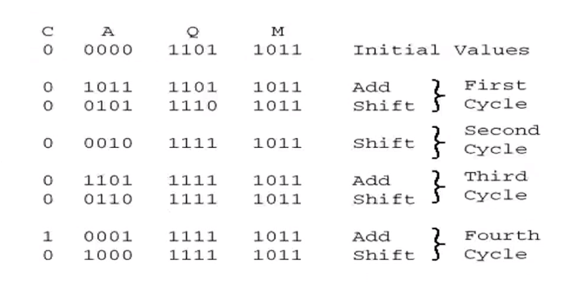

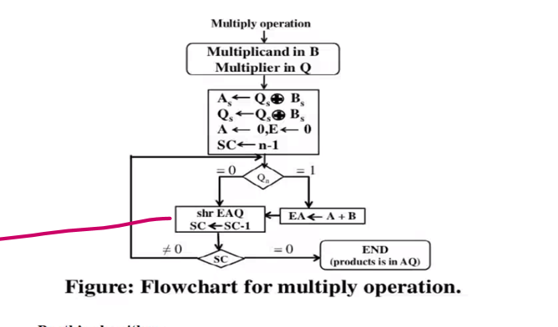

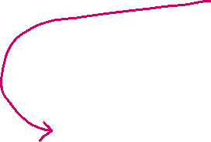

SC 🡪 sequence counter 0 to 4 [5 times] so only n-1

Shift right

# 

Initially sc🡪5 (number of bits in Q) .  
After Shift EAQ draw a line and then sc=sc-1

Booth Algorithm

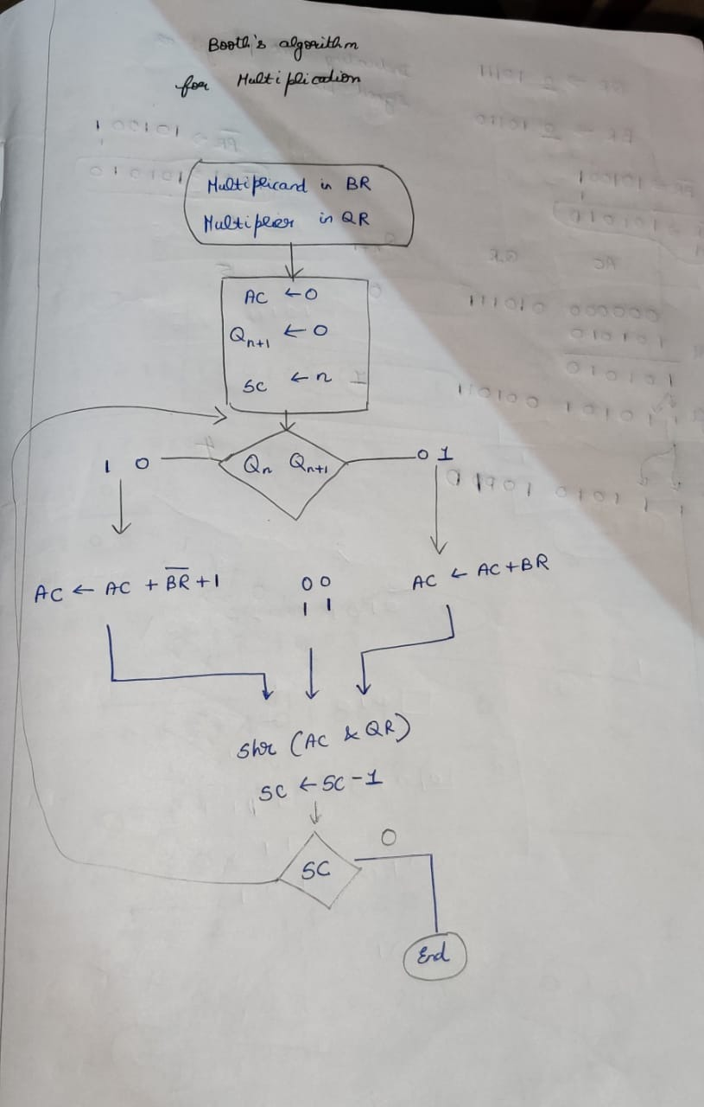

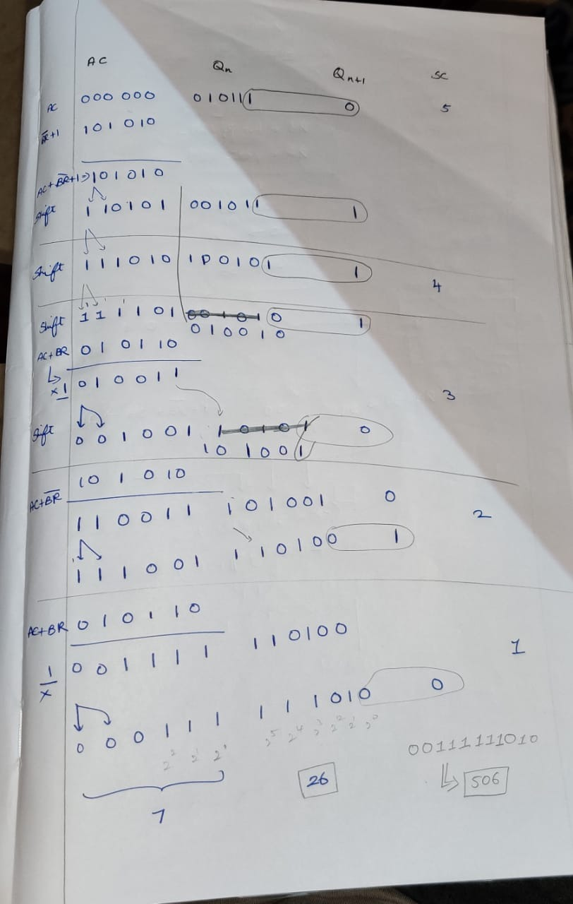

**Restoring Division Algorithm**

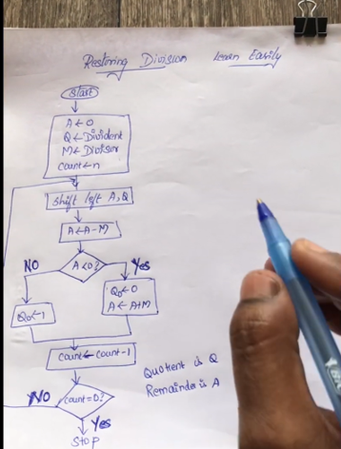x

Accumulator 🡪 Remainder  
Q 🡪 quotient

Accumulator 🡪 Q’s bit (+1)   
M 🡪 Accumulator bits  
count 🡪 Q’s bit   
Now with the changed M (do 2’s complement

**Non-Restoring Division Algorithm**

-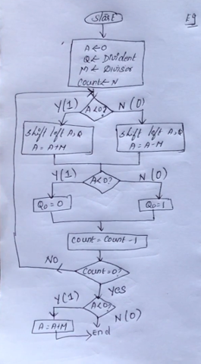

Accumulator 🡪 Q’s bit (+1)   
M 🡪 Accumulator bits  
count 🡪 Q’s bit   
Now with the changed M (do 2’s complement

**Ans:**

Accumulator 🡪 Remainder  
Q 🡪 quotient

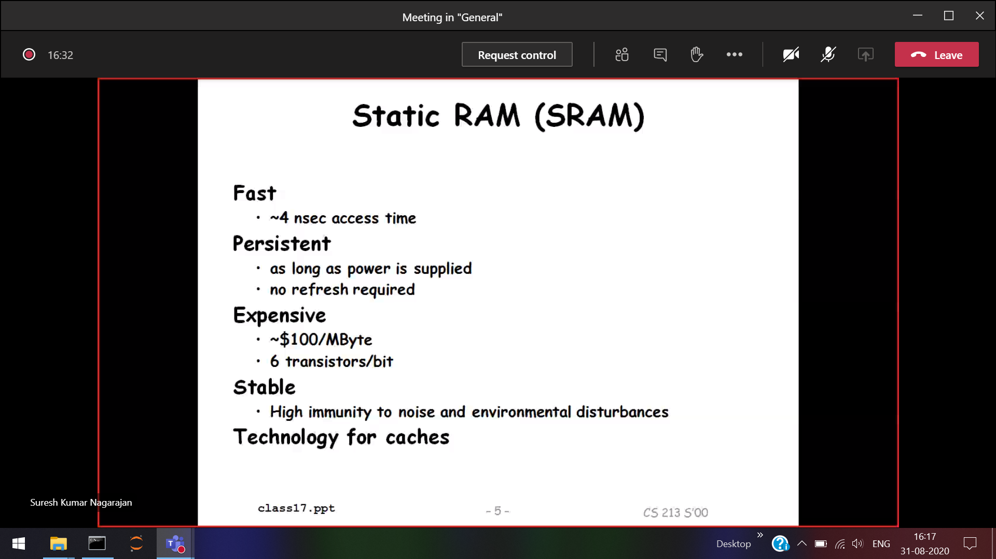

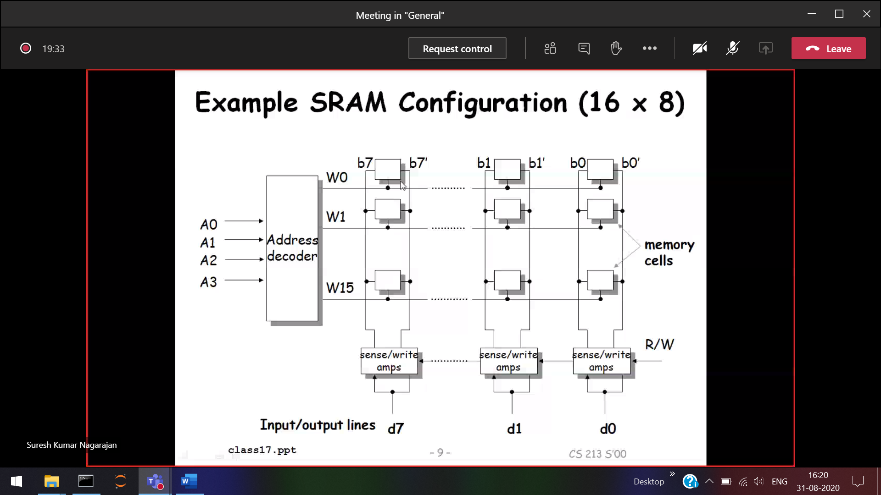Like matrix (16*8)

2^4 🡪 16  
Address decoder 🡪

16 bit 🡪 2^4 (A0,a1,a2,a3)

32 bit 🡪 2^5 (A0,a1,a2,a3,a4)

Read/write heads 🡪 sense/write

Output 🡪 d7,d1,d0

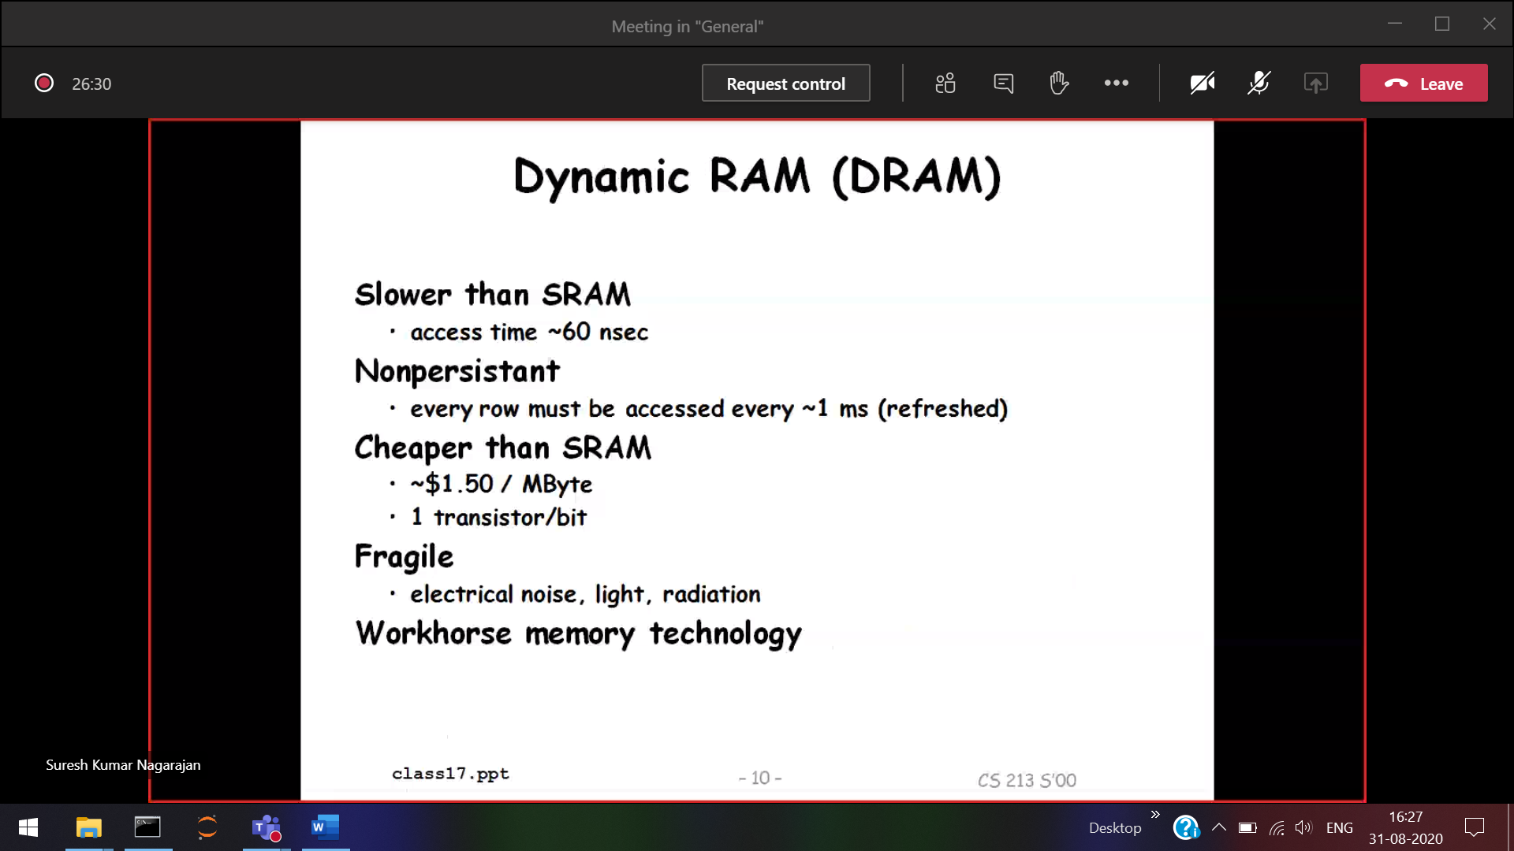

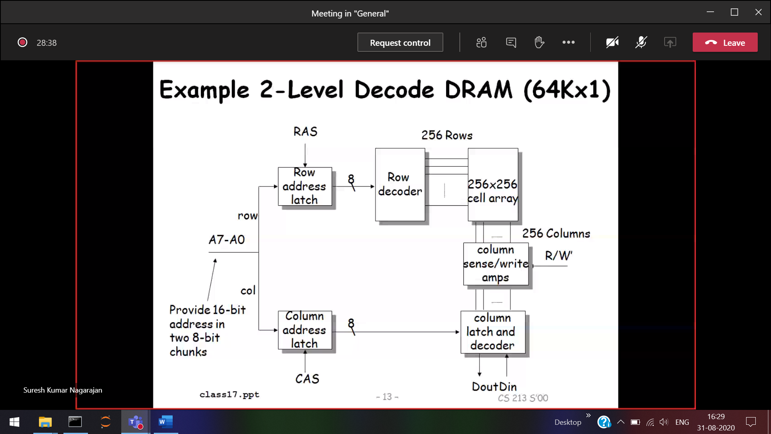

A0-A7  
A8-A14

Row address latch 🡪 To identify the row

1. 2^8 🡪 256



128K * 1 16



16



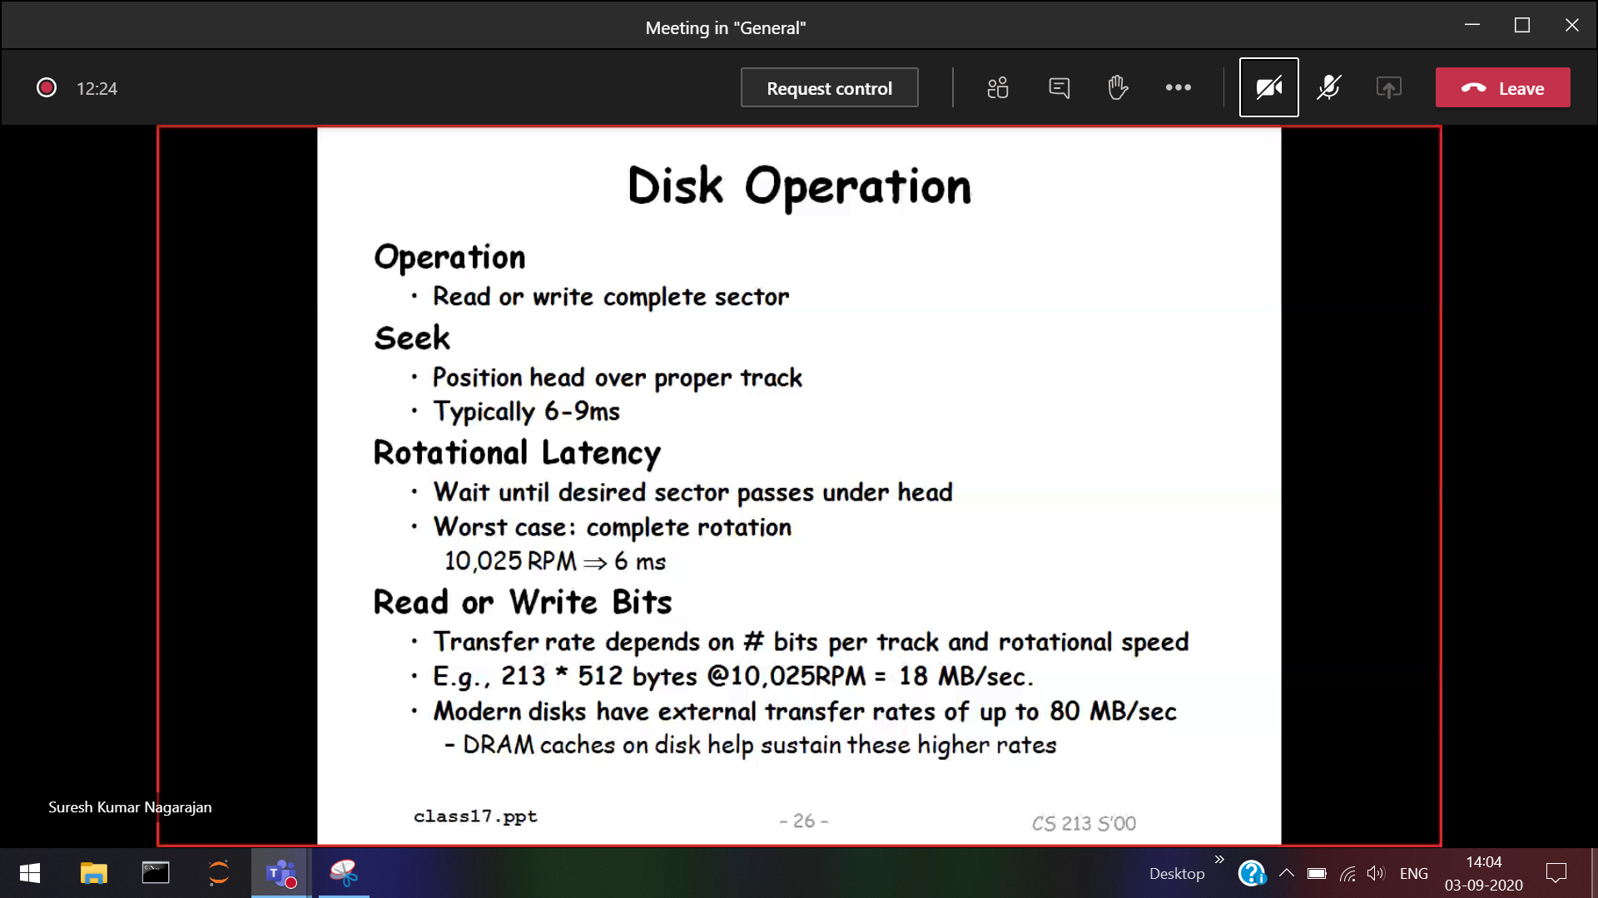

To take the head to a particular position

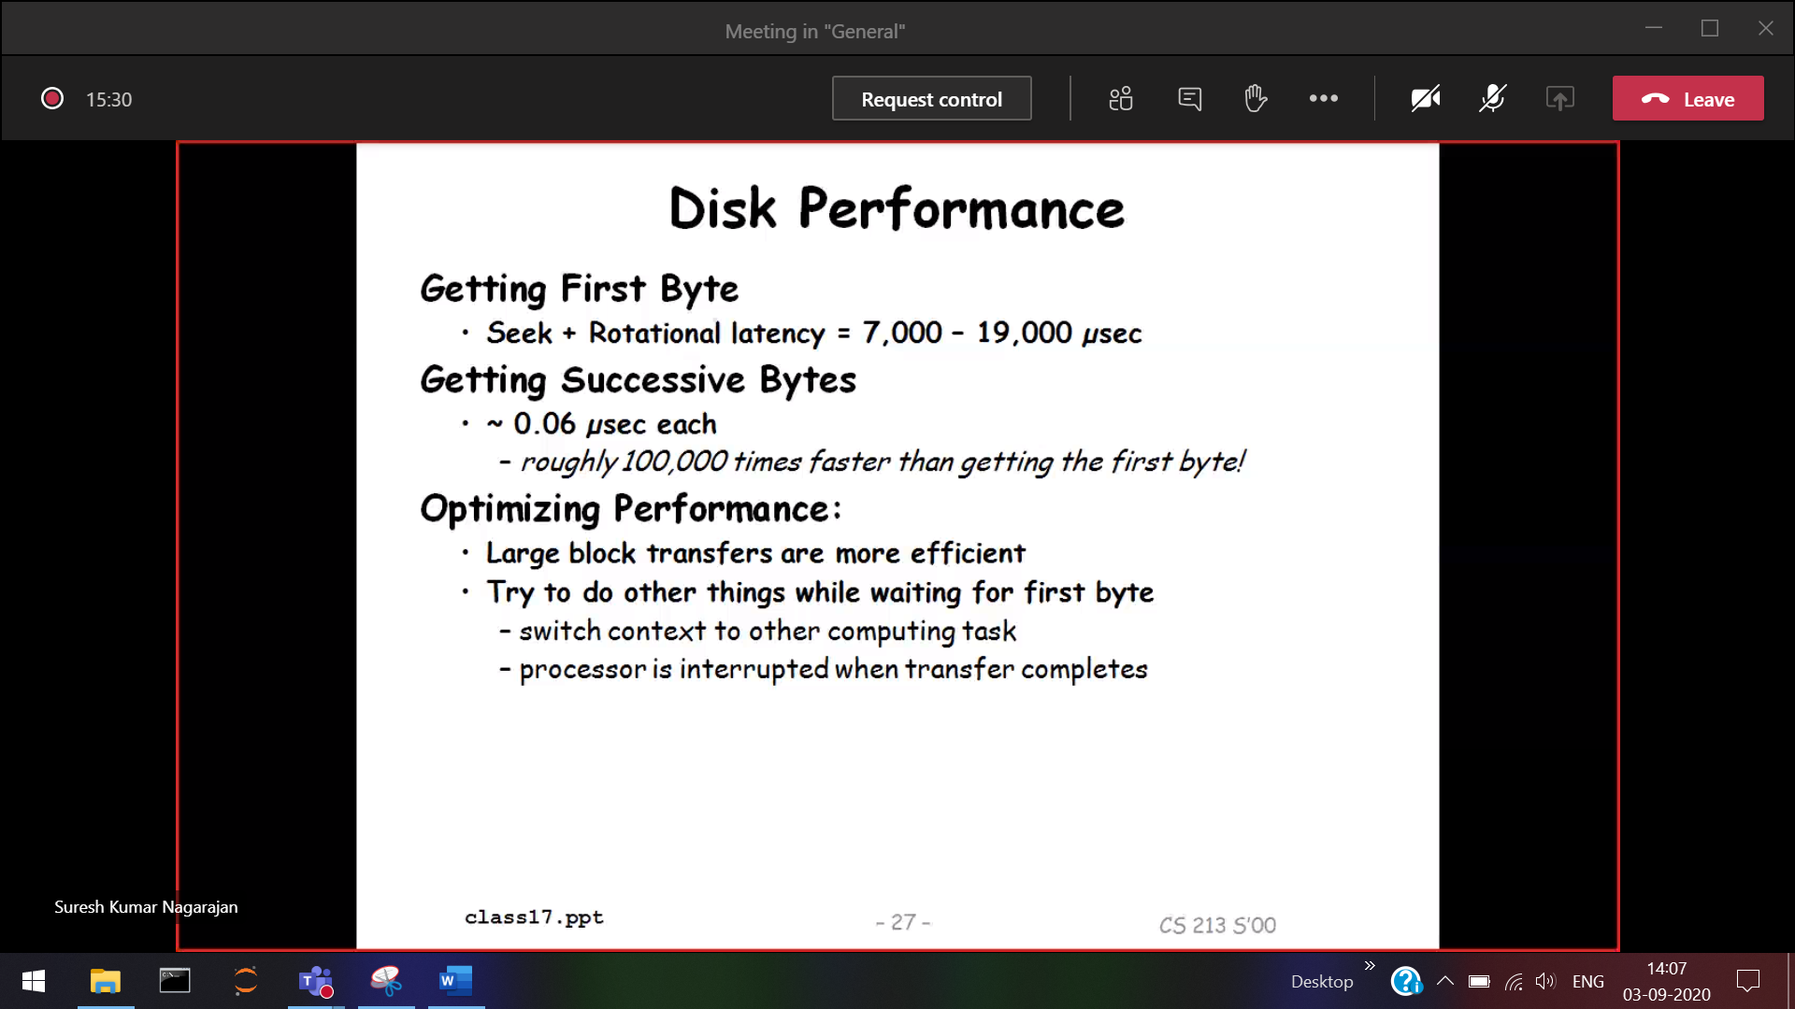

Successive bytes will be faster , since the particular block is identified

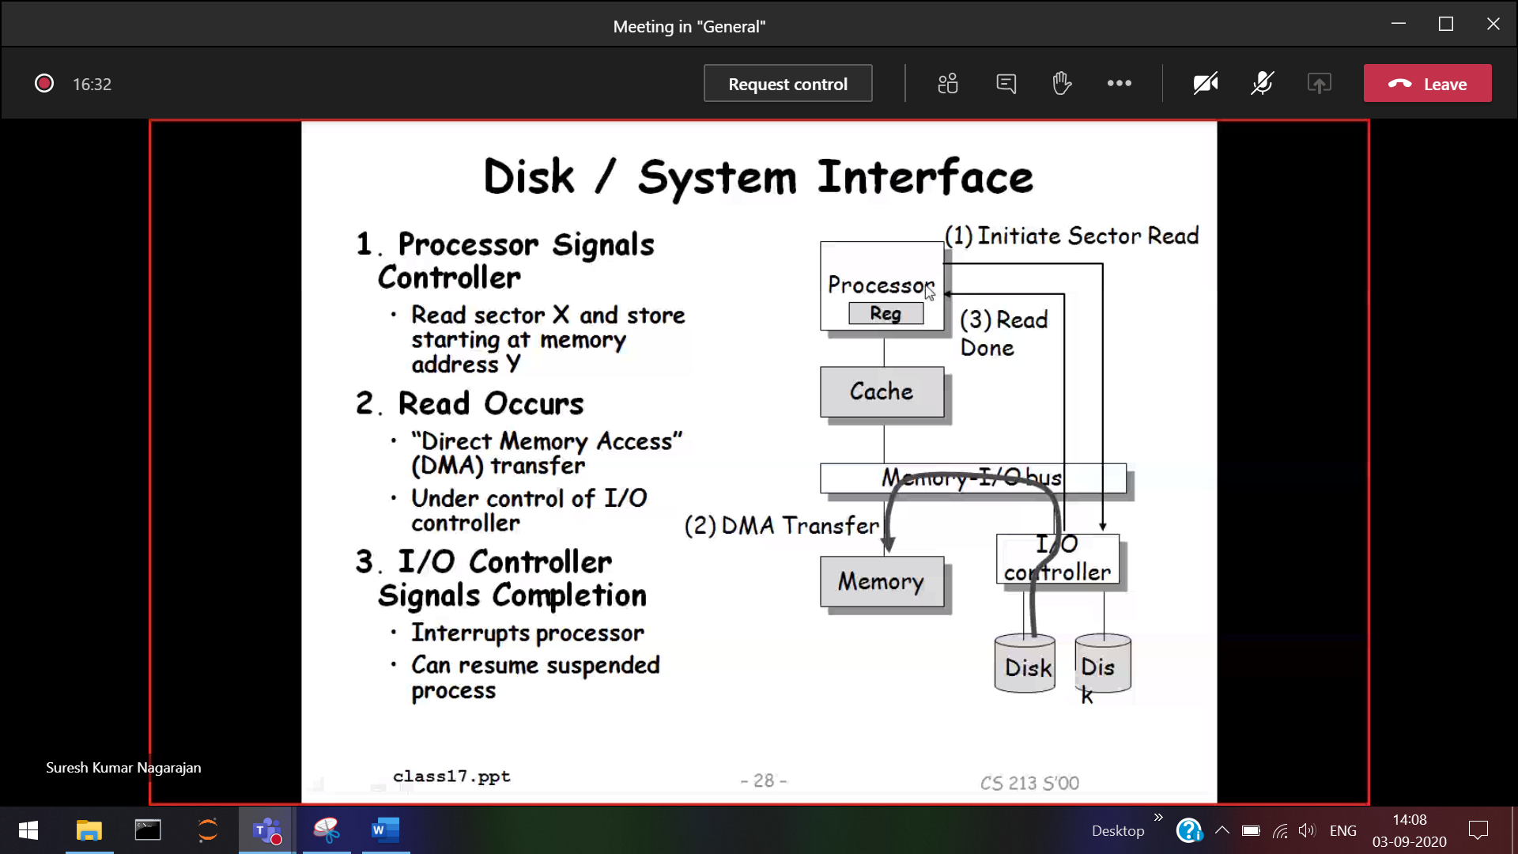



DMA 🡪 Disk is accessing Memory without involving the processor. Only processor initiates.

Memory I/O bus

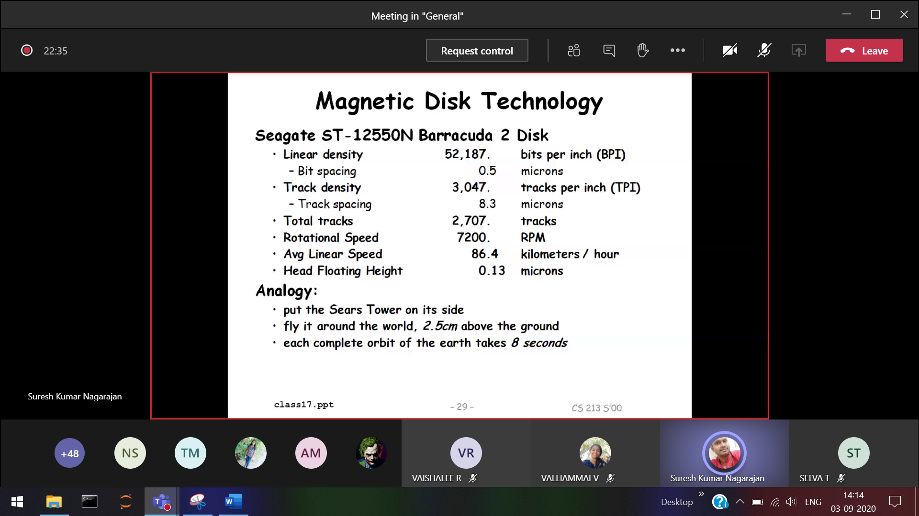

Bit spacing 🡪 Between two bits

Assignment 🡪 latest disk info

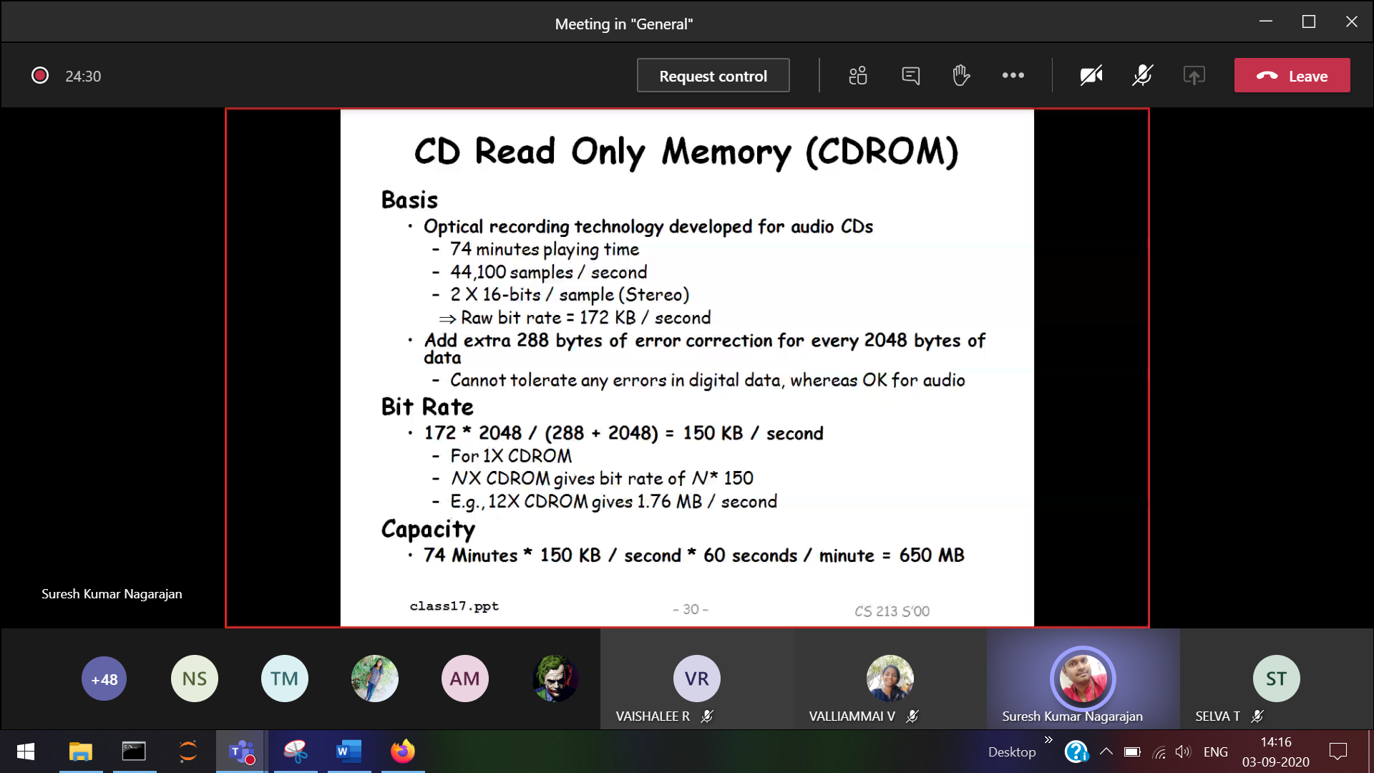

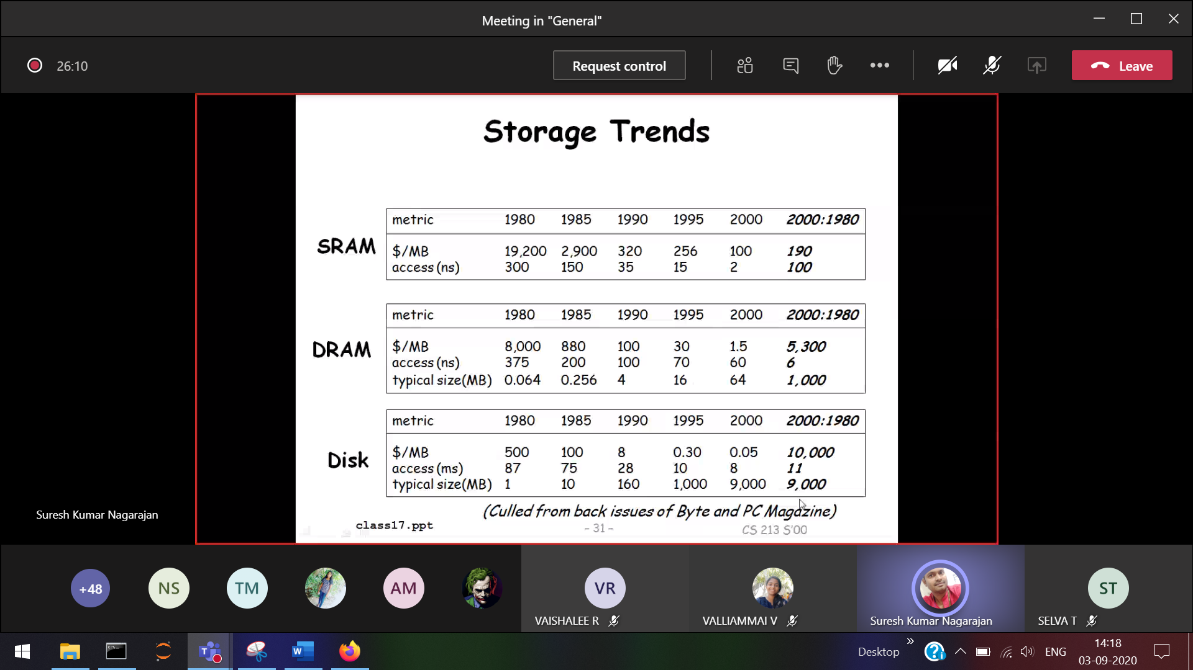

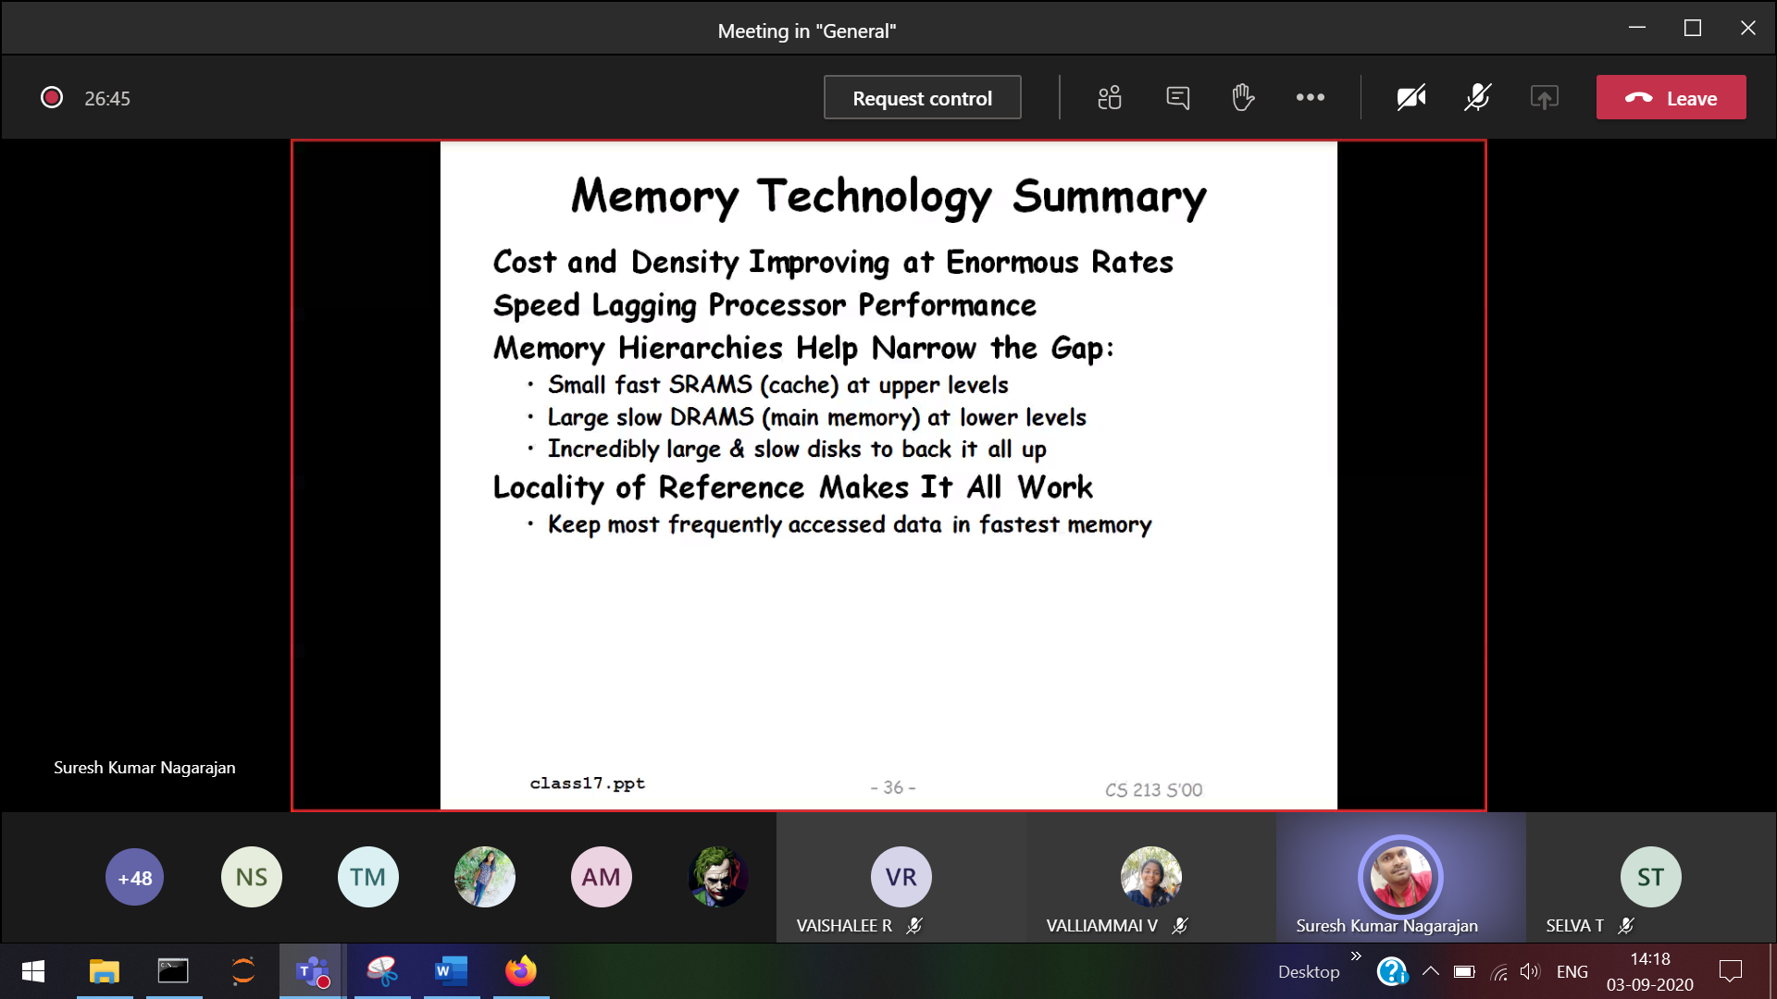

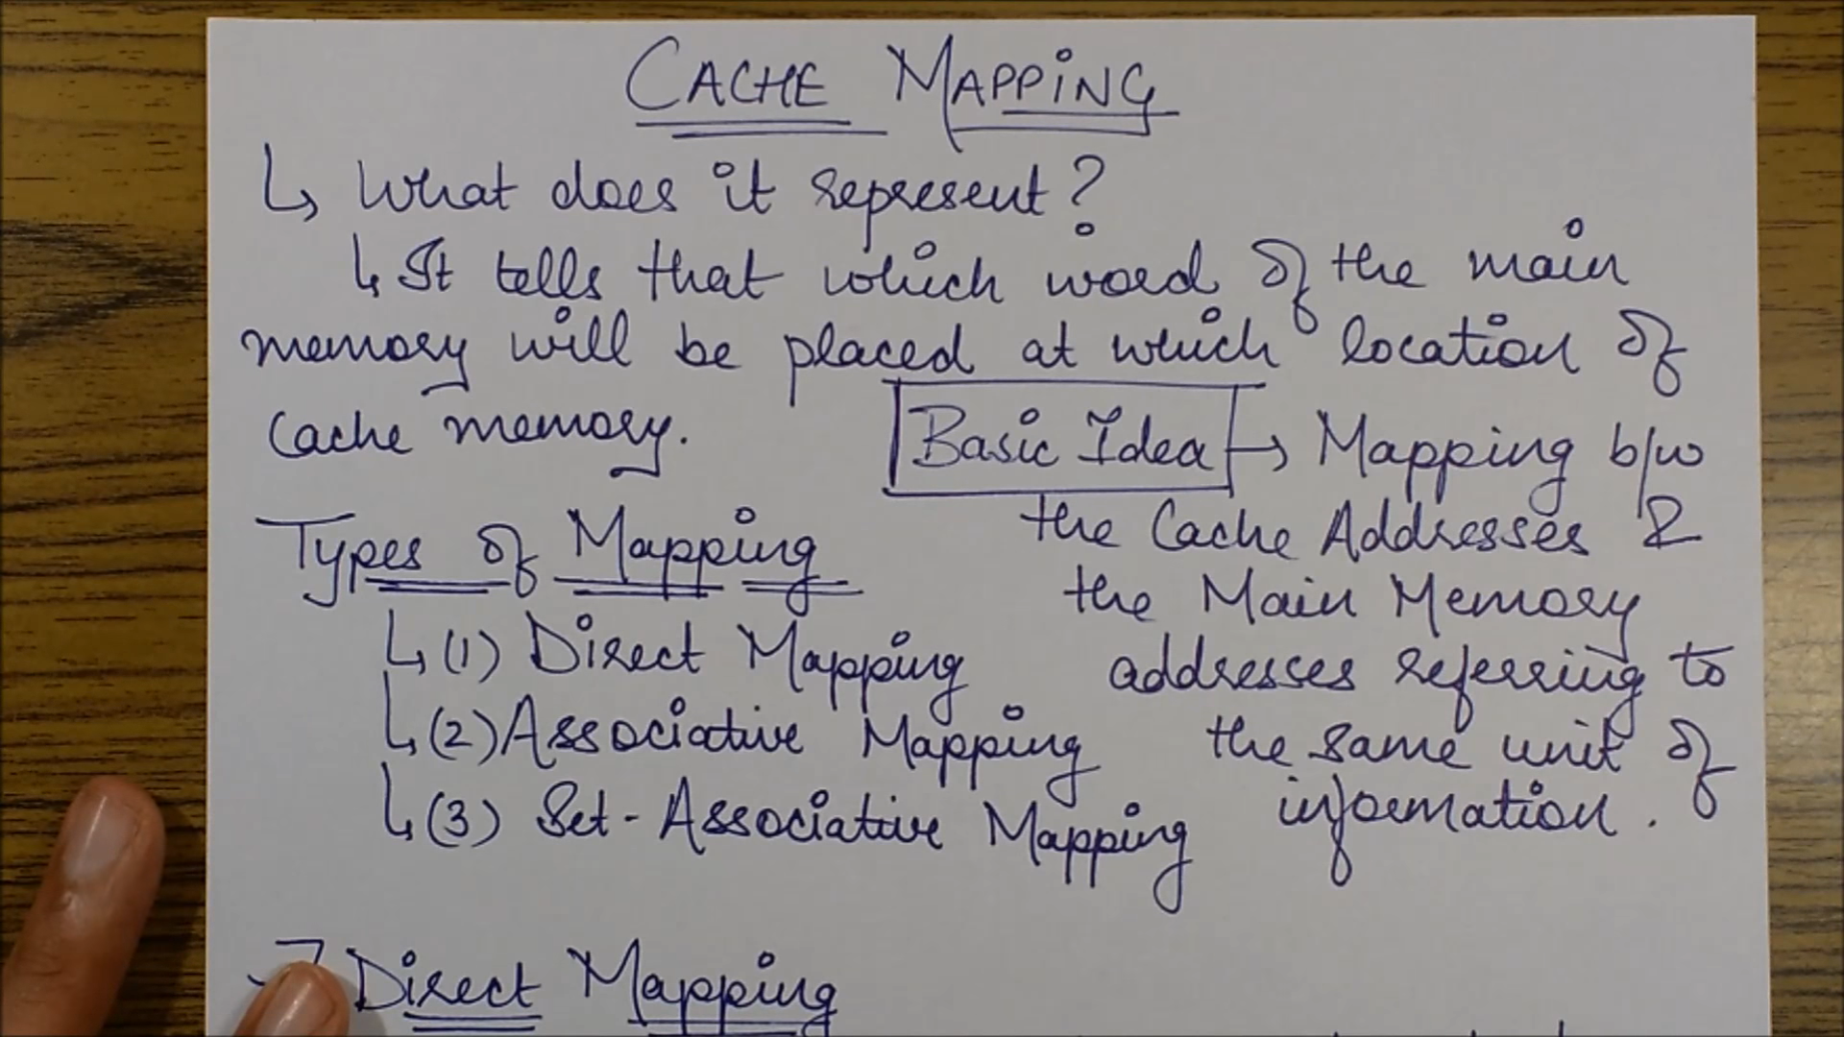  
Modifying the cache memory immediately should affect the main memory . So only mapping procedure is done.

**Write back** : Data after Remove from cache memory and restored in main memory.

**Write true** : Whenever some changes done in cache it has to immediately affect the main memory.  
For this two process mapping is required.

**Direct mapping :**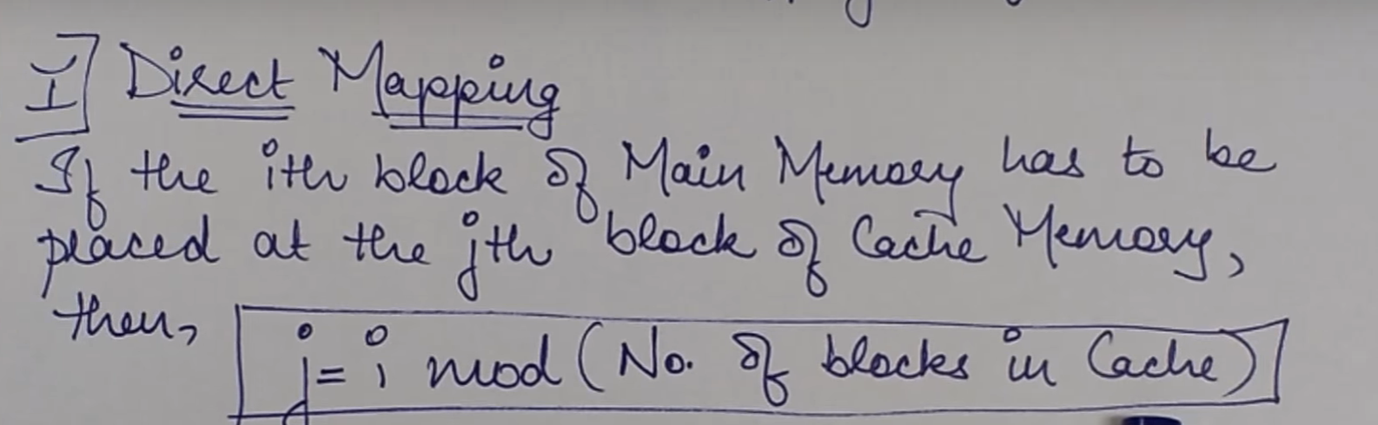

jth block of = ith block of % ( Number of blocks in cache cache memory main memory memory)  
 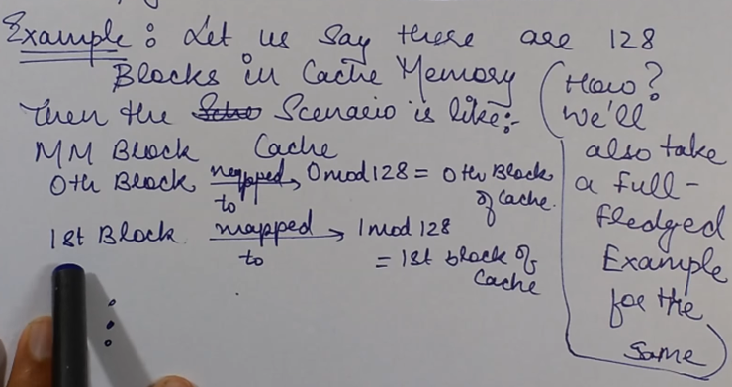

Number of blocks in cache memory 🡪 128 blocks

**Cache 🡪 128 MB 0**



**Main memory 🡪 1024 MB 0 128 512 1024**

i=0 (1st time j=0)   
i=128 (then j=0) again Mapped to the 0th location in cache memory)  
i=512 (then j=0) again Mapped to the 0th location in cache memory)  
i=1024 (then j=0) again Mapped to the 0th location in cache memory)

This is the main dis-advantage. To overcome 🡪 **Associative mapping**

**Associative Mapping :**

Now any block of the main memory can be placed anywhere in the cache memory.   
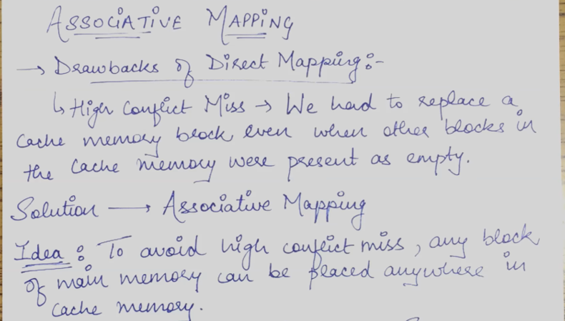

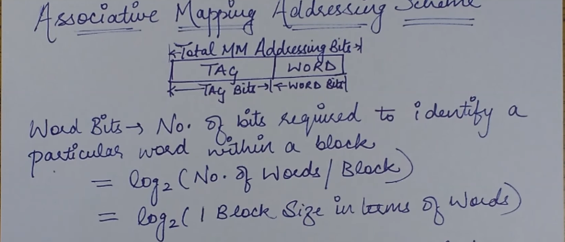  
Word bits 🡪 log2(Number of words in a block)

Tag bits 🡪 to identify a particular block in the main memory.  
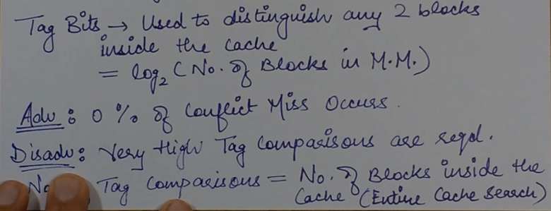

**Set Associative Mapping**   
Need of set associative mapping

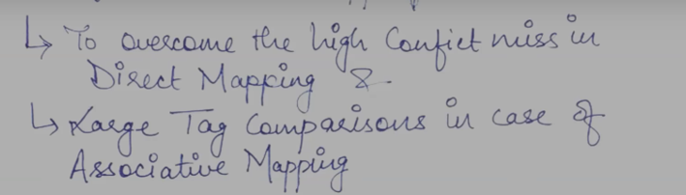

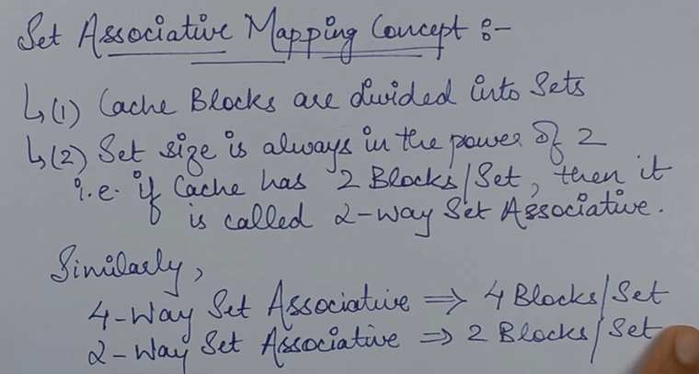

Particular block of the main memory 🡪 Particular set of cache.  
Within that set any of the blocks can be mapped.

2 way set Associative ( 2 blocks/set) 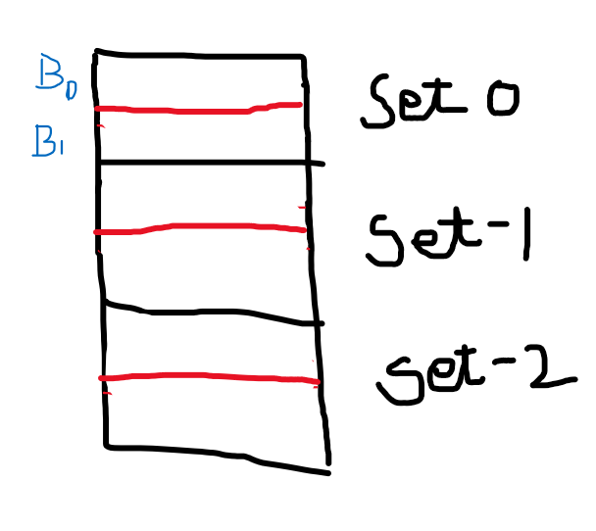

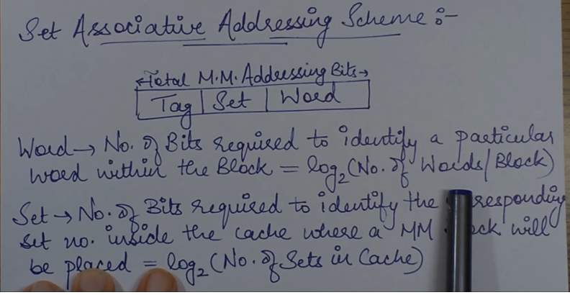  
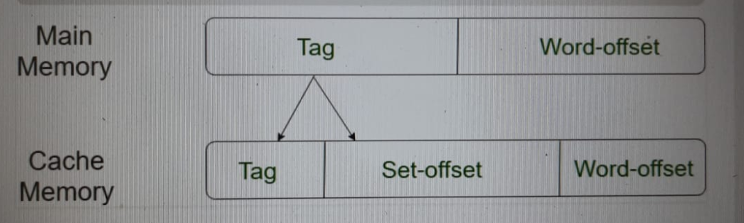

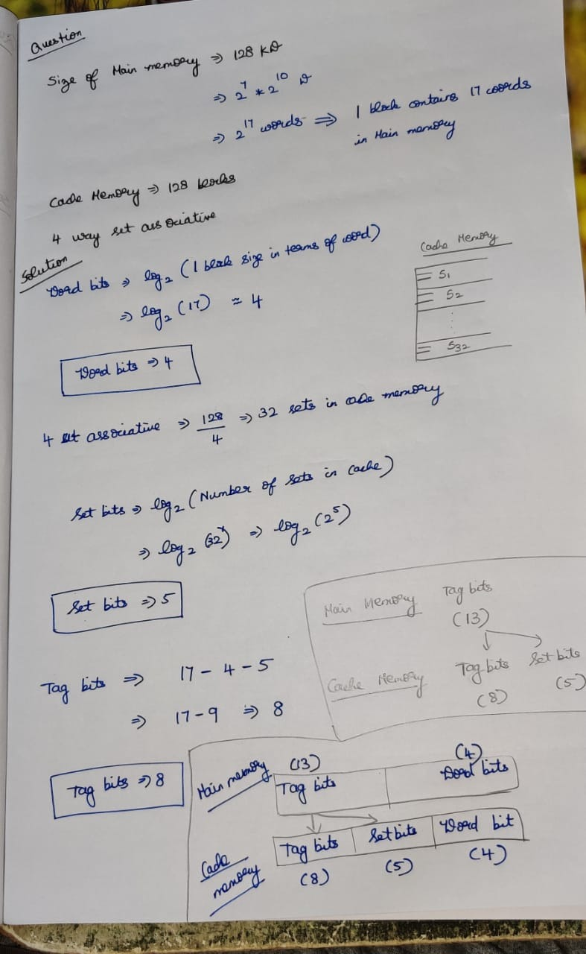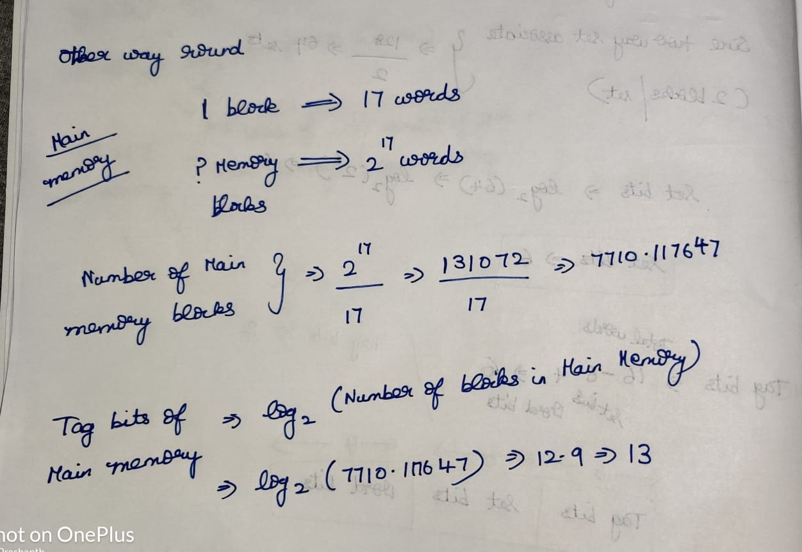

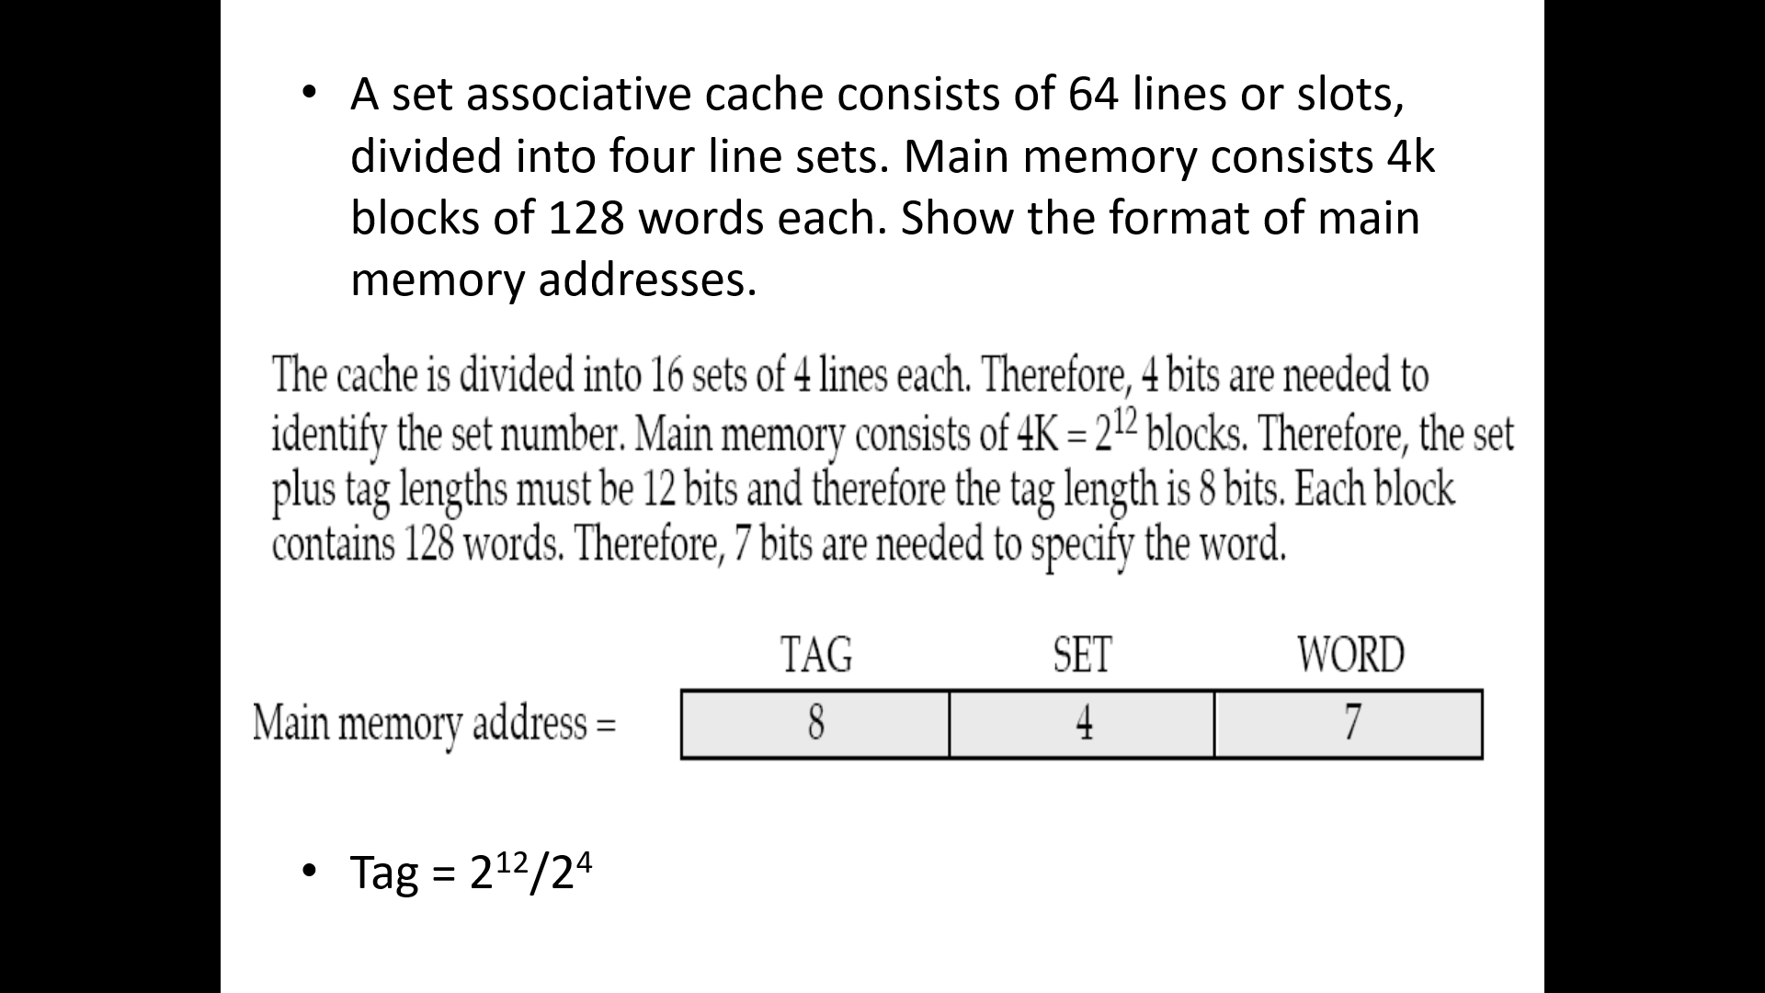

**Associate mapping**

Wherever the free space available

Every-time tab is used to add the data in cache memory

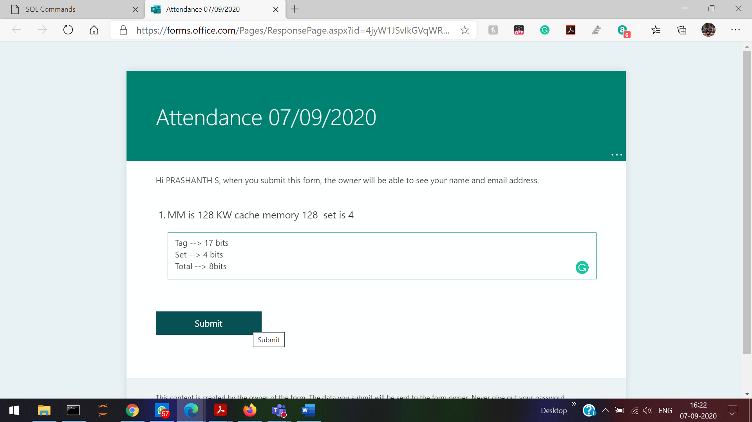

**Page replacement algorithm**  
Whenever the cache memory is full, some data has to be removed from. So on which order the data is removed 🡪 Decided by page replacement algorithm.

Process size is more than main memory/physical memory. So it is not possible to load the entire process into the main memory. So we are dividing the process into equal sized pages. So that other process too can be loaded into the main memory   
Process is divided into equally sized pages

Some portions of hard-disk 🡪 Virtual memory

**Page fault** 🡪 When the needed/required page for that particular process demanded by the CPU is not available in the main-memory, then that condition is known as page fault.

**Now what to do???**

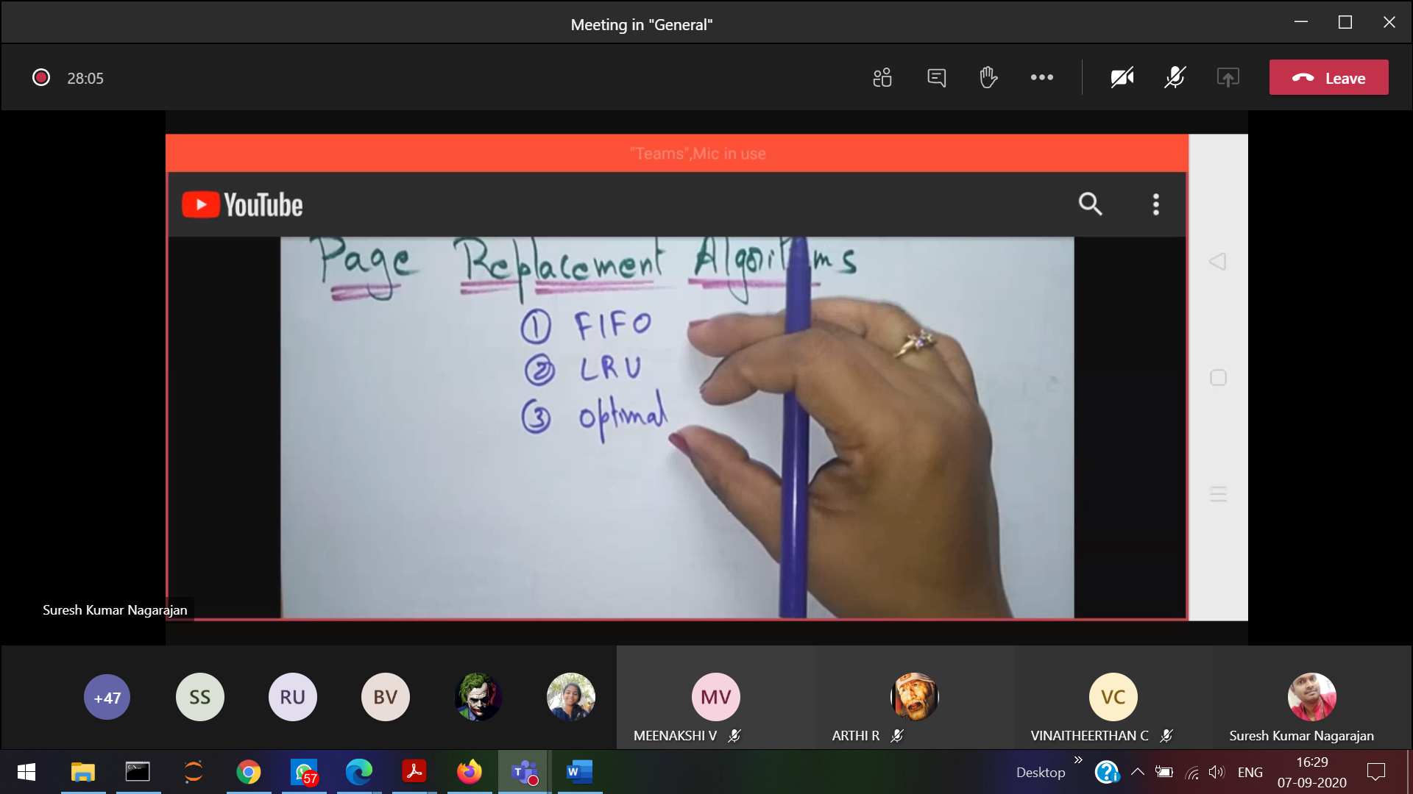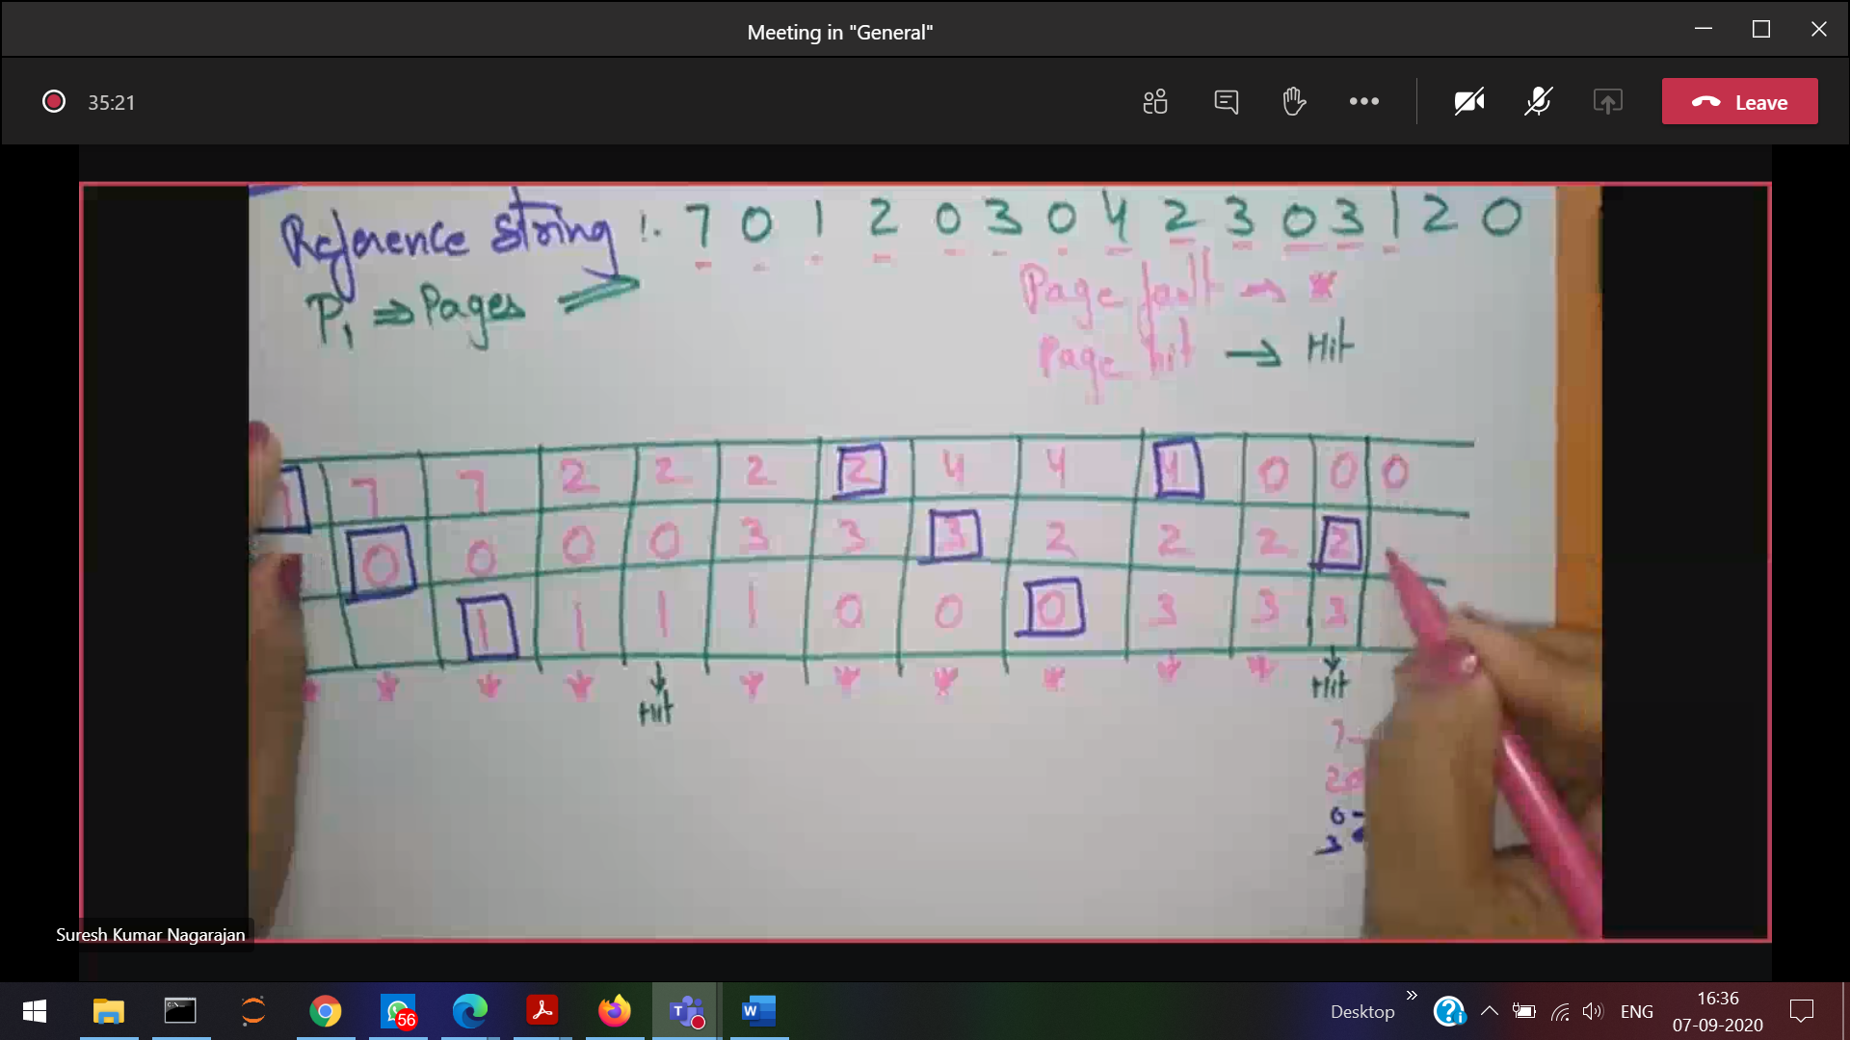

Reference string 121234344456789  
Cache size is 3 calculate page fault rate and page hit rate

Virtual memory

Gives an illusion of having larger memory

Virtual memory Memory mapping RAM